SIMATS ENGINEERING
ASSESSMENT TOOL 3
Case Study

NAME:G.Devila
REG NO: 192371086
COURSE NAME: Internet Programming
COURSE CODE: CSA4308

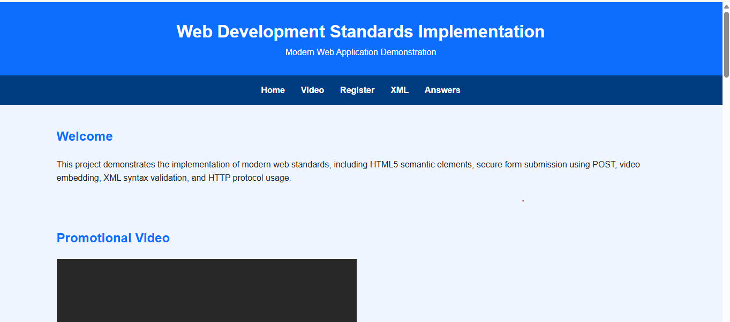

Question 1
Correct Answer: B
The HTML5 <video> element is specifically designed for embedding videos. It supports controls, autoplay, muted, loop, subtitles and multiple formats.

Question 2
Correct Answer: POST
POST securely sends form data inside the request body, making it suitable for registration forms because sensitive information is not exposed in the URL.

Question 3
Correct Answer: <nav>
The semantic <nav> element represents navigation links. It improves accessibility, SEO, and document structure.

Question 4
Correct Answer:

<note>
<to>User</to>
<from>Admin</from>
</note>

Errors in other options
- Option A → Missing closing </note>
- Option C → Closing tag mismatch (</from>)
- Option D → Missing > and incomplete closing tag

Question 5
Correct Answer: HTTP
HTTP (HyperText Transfer Protocol) enables communication between web browsers and web servers. HTTPS is the secure version used in production environments.

1. Select the correct HTML tag for video embedding and justify your answer.
Correct Answer: B. <video src="video.mp4" controls></video>
Justification:
- The <video> tag is the standard HTML5 element used to embed video content on a webpage.
- The controls attribute provides built-in playback controls such as Play, Pause, Volume, and Full Screen.
- It supports multiple video formats (MP4, WebM, OGG) and is supported by all modern web browsers.
- The other options (<media>, <movie>, and <vid>) are not valid HTML elements.

2. Identify the appropriate HTTP method for form submission and explain why.
Correct Answer: B. POST
Explanation:
- The POST method is used to send form data securely to the server.
- The submitted data is placed in the request body, so it is not visible in the URL.
- It is suitable for registration forms because it can safely transmit sensitive information such as passwords and personal details.
- GET is mainly used for retrieving data and appends information to the URL, making it unsuitable for sensitive data.

3. Choose the proper semantic element for navigation and justify its usage.
Correct Answer: B. <nav>
Justification:
- The <nav> element is the semantic HTML5 tag specifically designed for navigation links.
- It helps browsers, search engines, and assistive technologies identify the website's navigation section.
- Using <nav> improves accessibility, SEO, and the overall document structure.
- Other elements like <div>, <section>, and <header> do not specifically represent navigation.

4. Identify the correct XML syntax and explain the error in other options.
Correct Answer:
<note>
<to>User</to>
<from>Admin</from>
</note>
Explanation:
This XML is correct because:
- Every opening tag has a matching closing tag.
- Tags are properly nested.
- There is a single root element (<note>).
Errors in the other options:
- Option A: Missing the closing </note> tag.
- Option C: Incorrect closing tag (</from> is used instead of </to>), causing a tag mismatch.
- Option D: The closing tag is incomplete (</note is missing the closing >), making the XML invalid.

5. Choose the correct protocol for web communication and justify your choice.
Correct Answer: B. HTTP
Justification:
- HTTP (HyperText Transfer Protocol) is the standard protocol used for communication between web browsers and web servers.
- It enables the transfer of web pages, images, videos, and other web resources.
- HTTPS is the secure version of HTTP and is commonly used for secure websites.
- The other protocols serve different purposes:
  - FTP – File transfer.
  - SMTP – Sending emails.
  - SNMP – Network device monitoring and management.

